Using a qualitative model to explore impacts of ecosystem and anthropogenic drivers upon declining marine survival in Pacific Salmon

Kathryn L. Sobocinski*,1,2, Correigh M. Greene1, M. Schmidt2

v.8 (Formatted)

February 21, 2017

Journal Target: [*Environmental Conservation*](https://www.cambridge.org/core/journals/environmental-conservation)

1Northwest Fisheries Science Center

National Marine Fisheries Service

National Oceanic and Atmospheric Administration

2725 Montlake Blvd. E

Seattle, WA 98112

2Long Live the Kings

1326 5th Ave. #450

Seattle, WA 98101

*Corresponding Author:

kathryn.sobocinski@noaa.gov

(206) 302-2466

Word Count (including references and legends):

# Summary

Coho salmon (*Oncorhynchus kisutch*), Chinook salmon (*O. tshawytscha*), and steelhead (*O. mykiss*) in Puget Sound and the Strait of Georgia have exhibited declines in marine survival over the last 40 years. While the cause of these declines is unknown, multiple factors, acting cumulatively or synergistically, have likely contributed. To evaluate the potential contribution of a broad suite of drivers on salmon survival, we used qualitative network modeling (QNM). QNM is a conceptually based tool that uses networks with specified relationships among the variables. In a simulation framework, linkages within the networks are weighted and then subjected to user-specified perturbations. Our network comprised 33 variables, including: environmental and oceanographic drivers (e.g., temperature, precipitation), primary production variables, food web components from zooplankton to top predators, and anthropogenic impacts (e.g., habitat loss, hatcheries). We included salmon traits (survival, abundance, residence time, fitness, and size) as response variables. We invoked perturbations to each node and to suites of drivers and evaluated the responses of these variables. The model showed that anthropogenic impacts resulted in the strongest negative responses in salmon survival and abundance. Additionally, feedbacks through the food web were strong, beginning with primary production, suggesting that several food web variables may be important in mediating effects on salmon survival within the system. With this model, we were able to compare the relative influence of multiple drivers on salmon survival.

# Introduction

Problems of complex interactions are common in many fields, including medicine, economics, and ecology (Levins 1974). In ecology, much attention has been given to describing food webs and interactions among species (Paine 1966, May 1974, Pimm et al. 1991, Dunne et al. 2002a). But often, these food webs are nested within larger ecological or social-ecological contexts where exogenous forces influence components of the food web system. External forcings may include physical drivers, anthropogenic impacts, or ecosystem components that are not characterized within the focal network. In social-environmental systems, tools that incorporate ecological properties, abiotic variables, and management actions within the same analytical framework are needed to accurately understand the dynamics of complex systems and evaluate potential management actions (Liu et al. 2007). However, rarely are compatible datasets available for this type of analysis. In marine ecosystem management, complicated end-to-end models such as *Atlantis* are coming to the forefront (Ainsworth et al. 2010, Fulton et al. 2011), but these models are complex, data-intensive, and require high levels of expertise to develop and run. Here we use a qualitative network model, a conceptually based modeling approach, and a suite of simulations to address questions about the relative impacts of human and natural influences on early marine survival of juvenile salmon.

In recent years, attention has turned to early marine life-history stages of Pacific salmon (*Oncorhynchus* spp.) in an effort to understand population declines and the subsequent failure to rebound, given myriad conservation and restoration efforts in freshwater streams. In Chinook salmon, Coho salmon, and steelhead (*O. tshawytscha*, *O. kisutch*, and *O. mykiss*, respectively), declines in survival have been evidenced within Puget Sound, WA, USA and the Strait of Georgia, BC, Canada that have not been seen in coastal populations (Beamish et al. 2010, Johannessen and McCarter 2010, Zimmerman et al. 2015, Ruff et al. in press, Kendall et al. XXXX). These inland water bodies, collectively the Salish Sea, serve as habitats for juvenile salmon as they pass from natal streams to ocean waters during their outmigration. Yet, because of complex anthropogenic changes brought about by population increases and the associated human activity in these coastal waters, it is likely that a number of factors and their cumulative—synergistic or additive—effects are contributing to increasing marine mortality. Other salmon species, such as Chum, Pink and Sockeye salmon (*O. keta*, *O. gorbuscha*, and *O. nerka*, respectively), have not experienced similar declines (Debertin et al. 2017), suggesting that life-history characteristics may contribute to increased mortality for some species in this region. Teasing apart which factors have negatively impacted survival of juvenile salmon in marine waters is of concern to local, regional, and federal governments and other stakeholders (e.g., Salish Sea Marine Survival Project, <http://marinesurvivalproject.com/>) and management actions are sought to lessen impacts and increase survival during this period.

Correlative studies of salmon abundance and environmental factors have been on-going in the greater region for many years (Pearcy 1988, Beamish et al. 2000, Teo et al. 2009, Burke et al. 2013). Additionally, food web models have been developed for the Strait of Georgia (Priekshot 2008) and Puget Sound (Harvey et al. 2012). These models show the importance of primary production for driving the biological system, but also the effect of top predators in creating trophic cascades and influencing food web dynamics in the mid-trophic levels (Harvey et al. 2012), where time-series data are sparse. Even with an understanding of the main variables in a given system, measuring abundances of each variable and the flux of material/energy among them often poses a logistical challenge (Christensen and Walters 2004). Additionally, these models do not easily incorporate non-fisheries anthropogenic impacts, such as habitat loss or contaminant exposure; it is the rare system that is ever completely specified (Levins 1974), yet we understand that in many systems diverse but cumulative impacts can play a role in species population change. For this reason, conceptually based models, incorporating a broader array of variables, are an important tool in modeling and can provide an integrated picture of ecological and human drivers of ecosystem change.

One tool for evaluating the relative influence of ecosystem components is Qualitative Network Modeling (QNM, also called Qualitative Network Analysis, QNA, or Loop Analysis, Levins 1974, Puccia and Levins 1985, Raymond et al. 2011, Melbourne-Thomas et al. 2012, Harvey et al. 2016). This approach is advantageous for understanding a system of complex interactions which may not be fully specified and when precise measurement is impossible, but when a mechanistic understanding of interactions exists. It also allows the testing of competing hypotheses, given different model structures or the invocation of perturbations to one or more of the model variables. QNM does not explicitly include magnitudes of change or non-linear direct effects, both of which occur in and influence social and ecological systems. However, QNM may help to determine the relative impacts of competing hypothesized factors or indicate where empirical work could be focused to improve system understanding (Levins 1974), focusing future research efforts.

Researchers have used QNM for evaluating ecosystem response to ocean acidification in shellfish management (Reum et al. 2015), the impacts of eutrophication and species management within a food web (Carey et al 2013), and for discerning the impact of management actions for species recovery (Harvey et al. 2016) in the Pacific Northwest. QNM is an important conceptual tool for discerning relative impacts of ecosystem components from which more complex, data-driven modeling efforts can stem. Here we apply this technique to evaluate a suite of potential drivers thought to be contributing to increased early marine mortality in a group of Pacific salmon in the Salish Sea. Using a simulation framework, we invoke perturbations to each model variable and suites of variables based on salmon early marine survival hypotheses, and assess model response related to the salmon species of concern. This work is a foundational step in understanding the impacts of multiple drivers of marine survival declines in Salish Sea salmon.

# Methods

We used QNM to address our main question of the relative impacts of various factors on salmon early marine survival. Our analysis had three main steps: 1.) Construct an enhanced conceptual model showing positive, negative, and neutral relationships using a digraph; 2.) Generate a pool of stable simulated models, with random weights applied to each model linkage; and 3.) Invoke one or more perturbations based upon mechanistic understanding of the system and determine the model response. We describe these steps in detail below.

## Conceptual Model

To construct our conceptual model of the Salish Sea system, we gathered existing literature and experts on ecosystem components from the project technical team and iteratively developed a working conceptual model. We began by developing a list of over 40 possible variables to consider. These variables were drawn from hypotheses about the decline of Pacific salmon within the system (Salish Sea Marine Survival Project hypotheses, <http://marinesurvivalproject.com/the-project/key-hypotheses/>), and included: physical forcings (e.g. sunlight, precipitation), biological components from primary production (e.g., diatoms) to top predators (e.g., marine mammals, piscivorous birds) and competitors (e.g., forage fishes, piscivorous fish), and anthropogenic variables (e.g., hatcheries, habitat loss). While the conceptual model is not exhaustive, it does include many of the drivers identified in our working hypotheses and reflects many of the known interactions within the ecosystem.

Central to our approach was specifying multiple salmon characteristics as modeled network nodes, namely: size, fitness, residence time, abundance, and survival. We used these traits as primary response variables throughout our analysis. While marine survival (termed herein as “survival”) was our principal variable of interest (i.e., “What is causing declines in early marine survival?”), we included individual traits so that we could evaluate the relative impact of model variables on different metrics of salmon performance. The inclusion of model variables that are not biomass pools highlights the flexibility of the qualitative modeling approach. We grouped the other model variables into several major driver groups: environmental factors, primary production, food web interactions, and anthropogenic impacts, in addition to the salmon traits identified above (Table 1). Focusing on physical, bottom-up, top-down, and anthropogenic factors fit with the working hypotheses of the Marine Survival Project and enabled exploration of combinations of variables and drivers while including fundamental processes and relationships within the ecosystem (e.g., sunlight and nutrients positively affect primary production, habitat loss negatively affects salmon and forage fishes, etc.).

The emphasis of the modeling effort was on understanding sources of decreased survival and fitness of the focal salmon species (Coho, Chinook, and Steelhead), which have shown an overall declining population trend (Figure 1, left panel, Appendix 1 for details) in addition to a decline in marine survival (Zimmerman et al. 2015, Ruff et al. in press, Kendall et al. XXXX). We included a model variable “Other Salmon” because the migration timing of all Pacific salmon species means competitive interactions are likely. However, the species included in the “Other Salmon” variable, Pink, Chum, and Sockeye salmon, have not experienced the same negative population trends (Irvine and Ruggerone 2016, Figure 1, right panel, and Appendix 1 for details) and are seen as important to the analysis but different from the focal species. While the emphasis was on representing the most direct impacts to the focal salmon traits, we recognize that many of the model variables (e.g., temperature) could potentially have direct connections to other model nodes; we have included these where interactions were important for understanding implications for the focal salmon variables or where existing literature has shown strong connections.

We defined relationships among variables as positive, negative, or null, and these relationships were based upon mechanistic understanding of the Salish Sea system as portrayed in our conceptual model. To implement the simulation modeling, we developed a conceptual digraph using the directed graphing software, Dia (v.0.97.2), to represent the model system and the interactions among variables (Figure 2). This digraph served as the foundation for our qualitative modeling.

## Simulated Networks

We used the *QPress* package for Qualitative Network Analysis (Raymond et al. 2012) in R (R Core Team 2016), with custom modifications to interpret the conceptual digraph, construct simulated networks, and perform our analyses. The digraph is interpreted as an interaction matrix, **A**, where each directed pairwise interaction is representedas coefficients *aij*. **A** is treated similarly to a community interaction matrix, wherein the rate of change of any given node is a continuous function of all other interacting nodes (Levins 1974; Puccia and Levins 1985). The interacting components (i.e., model nodes) are set up as a series of differential equations:

$$\frac{dx_{i}}{dt}=f_{i}(x_{1},x_{2},…,x_{n}; c_{1}, c_{2}, …, c_{m})$$

where the rate of change in variable *xi*is a function *fi* of the other *n*-1 variables and their rate parameters, *c* (Raymond et al. 2011). Therefore, the coefficients *aij* describe the effect of a small change in the level of component *j* on the level of component *i*, as defined by the partial derivative *aij* = evaluated at the equilibrium(Raymond et al. 2011, Melbourne-Thomas et al. 2012).

Given a network model and corresponding interaction matrix, **A**, the *QPress* analysis package provides routines for evaluating the impact of a press perturbation to the system through simulation. For each simulation, a weight (drawn from a random uniform distribution, 0-1) was assigned to each linkage (edge). These weights were positive or negative depending upon the relationship between the two endpoints. If the resulting model with all assigned weights was stable (i.e., converged), the model was accepted. We simulated the network ~120,000 times to result in 10,000 stable simulated networks. We then assessed the proportion of model runs with positive, negative, and neutral responses given changes to particular nodes (see below).

To assess the sensitivity of the model linkages in the simulations, we calculated means and standard deviations of the weights for all linkages from the pool of accepted models. Our hypothesis was that some linkages would be more influential in model stability and that those with mean weights different than the expected mean (*µ*=0.5, given assignments that were random (*U(0,1)*)) would provide some indication of linkage sensitivity. We experimented with changing both distribution and the variance of the weighting scheme, but did not find large differences in results, so maintained the default weighting for our analyses. Additionally, we described network properties such as connectance and linkage density, calculated distance to the Survival node via pathways from each model variable to check for effects of model structure, and evaluated model behavior with the sequential addition of perturbed nodes and a set of “cumulative effects” of both influential and neutral nodes.

## Invoking Perturbations

To test a suite of hypotheses concerning drivers to the Salish Sea ecosystem, we developed *a priori* perturbations to invoke upon each model node (Table 2). The direction of the perturbation (increase or decrease) was based upon our understanding of the system, changes that have occurred concomitant with declines in salmon marine survival (since the 1970s), and expected impacts as a result of climate change and other anthropogenic change (Appendix 2). We employed several scenarios and modified the *QPress* functions to meet our analytical objectives.

First, we perturbed each node individually and observed outcomes to all other model variables. This allowed for a simple comparison of impacts from each node and the ability to compare the extent of the impact to that from any other node on the focal salmon metrics. Second, we evaluated the relative effects of different groups of drivers (Table 3). For example, we were interested in food web effects, so we simultaneously decreased the forage fish compartment, increased marine mammals, decreased piscivorous fish, and increased gelatinous zooplankton—trends that have been observed in Puget Sound—and observed the impacts to the other model components. For each driver group, we selected four nodes to perturb, thereby standardizing the level of change invoked. By comparing impacts to salmon traits from primary production, food web, environmental, and anthropogenic drivers, we were able to query the relative impacts of each of these groups to the salmon traits as response variables.

Finally, we developed scenarios based upon observed changes within three regions of Puget Sound to see how well the model reproduced cumulative impacts in terms of response to the focal salmon metrics, especially survival. The three regions were: a.) South Sound, with a known decline in salmon abundance and cumulative impacts including increased gelatinous zooplankton, nutrients, contaminants and hatchery production and decreased forage fish abundance, b.) Hood Canal, which has had relatively stable salmon abundances, but impacts in oceanography, including increased stratification and temperature and low dissolved oxygen, and c.) Central Basin which has shown a decline in salmon abundance, relatively less than South Sound, but with a different suite of cumulative impacts including habitat loss, contaminant input, and decreased primary production. The purpose of this third analysis was to see how well the model could replicate trends that have been observed in our system. In reality, causes of declining survival are likely multi-faceted, complex, and non-linear, and this modeling exercise allowed us to examine the relative influence of many factors within one modeling framework.

# Results

## Model

Our final conceptual model had 33 nodes including salmon traits and climate/atmospheric, oceanographic, primary production, food web, and anthropogenic drivers (Table 1, Fig. 2, Appendix 2). There were a total of 148 linkages out of 1089 potential linkages within the model. This gives a network density or connectance (realized linkages/potential linkages) of 0.136 and a linkage density (average # of linkages/node) of 4.48. Connectance has been linked with network stability in ecological networks (Dunne et al. 2002b). The most highly connected nodes were Temperature, Diatoms, and (salmon) Abundance with a total of 11 connections each; the Other Salmon node was both highly connected (10 linkages) and highly influenced by other variables (10 influencing nodes, Table 1). All nodes were a minimum “distance” of four nodes or fewer from survival, but the range of feedback linkages varied greatly, from 1 to 10. Each model node included a self-limiting loop to aid in model convergence; the exception was Survival, which was considered the primary variable of interest and was not constrained.

Our sensitivity analysis showed that most model edges (linkages between groups) were stable with regard to the weights applied in the simulation routine, with means from the pool of balanced models very close to the expected mean of 0.5 (>75% of 148 edges). However, some model linkages in the pool of accepted models had mean weights above or below the expected mean and we considered these model groups more sensitive (Fig. 3). Linkages among salmon traits were most sensitive, with means in the balanced models considerably higher or lower than the expected mean (e.g., Fitness to Size and Survival to Abundance, self-limiting loops on salmon traits). However, some food web components such as Ichthyoplankton and Forage Fish were also in the group of lower-than-expected model means, suggesting that certain food web pathway weights were sensitive in the model simulations. The links with bidirectional connectivity (positive feedbacks, e.g. Fitness to Size, arrows shown in royal blue in Fig. 2) tended to be the most sensitive to the weighting scheme, with lower-than-average weights resulting in balanced models. Model linkages with mean weights above the expected mean included many high trophic level linkages (e.g., Piscivorous Fish to Marine Mammals), as well as self-limiting loops (salmon traits especially), highly connected nodes (e.g. Zooplankton), and top-level predators (Marine Mammals and Piscivorous Birds). The linkages with both higher- and lower-than-expected means (that were not self-limiting loops) tended be highly connected food web components rather than anthropogenic impacts or physical drivers.

To assess whether the proximity of each model node to Survival influenced the outcomes of our analysis (i.e., are nodes more directly connected to Survival more likely to result in stronger outcomes?), we evaluated the proportion of negative results for Survival with the minimum nodal distance to Survival and found no relationship. Both closely connected nodes (minimum nodal distance of 1) and those more distant (≥2 nodes away), resulted in a range of negative responses (<20% to >95%) with respect to Survival. Thus, we do not believe the model structure strongly confounded our results.

## Perturbations

The results of the press perturbation to each node showed that anthropogenic impacts resulted in the strongest negative responses in salmon traits, specifically Survival and Abundance (Table 2, Appendix 3). Here we use “strength of response” to refer to the relative proportion of outcomes that were positive or negative given a perturbation—a strong response was when proportionally more simulated models had positive or negative responses for the node of interest, while a weak response resulted when the simulated outcomes were equally positive/negative, or more neutral in outcome. An increase in CO2 resulted in a strong positive response in Survival and Abundance; CO2 positively influences Diatoms in the model, with positive effects cascading through the food web. Conversely, a decrease in Diatoms (primary production) resulted in a strong negative response in Survival and Abundance, as well as negatives outcomes to Zooplankton and Turbidity. A direct perturbation to (decrease) to Zooplankton resulted in strong negative responses in Fitness and Size, but neutral results in Survival and Abundance. On the other hand, a direct decrease to Turbidity resulted in a strong positive response in the individual traits, Fitness and Size, but slightly negative responses in Survival and Abundance, population-level traits. This is despite the fact that Turbidity directly and positively effects Survival in the model; this relationship is a result of the association of Turbidity with primary production and the resulting predation dynamics in the model. A decrease in the predators (Piscivorous Fish and Birds) resulted in positive responses in Survival and Abundance. Marine Mammals, also known predators of salmon, but with increasing populations (and thus a positive perturbation), had a neutral response on all salmon response variables. Unexpectedly, increased Harvest had a positive effect on Survival; Harvest has a direct negative effect on Abundance within the model, but the feedback to Survival is mediated by the food web, specifically Forage Fish and Zooplankton, which may moderate the harvest impacts to Survival through reduced competition. This same result indicates that strong feedback mechanisms, like density dependence, were simulated by the model and highlights the importance of complex food web interactions for salmon survival.

The results of the driver group analysis, which evaluated cumulative impacts from one functional section of the network, showed anthropogenic impacts to have predominantly negative effects on Survival, Abundance, and Fitness, with over 85% of the simulations having negative responses within these model groups (Fig. 5). For the environmental driver group, most simulation results were positive for Survival and Abundance, and for the food web and primary production driver groups the results were equivocal, with approximately half the responses negative and the other half positive. The Other Salmon category had a positive response in both the food web and anthropogenic drivers simulations, indicating that conditions that are less favorable within the food web for the focal salmon species may not be detrimental for other species (with diets that tend to be more planktivorous and rearing times within the Salish Sea that are generally shorter). Interestingly, the food web manipulation yielded strong negative responses on the salmon individual traits (Size and Fitness) but more moderate negative response on the population-level traits (Abundance and Survival). In an analysis incorporating time, these negative impacts on individual-level traits would likely result in negative impacts to the population over some period.

For the regional differences, we modeled three regions of Puget Sound with different impacts and salmon population trends (as described above and Table 4). In general, our model replicated the actual trends in salmon survival within these regions, with strong negative responses in focal salmon Survival, Abundance, and Fitness in both South Sound and Central Basin. While the results for Hood Canal were more weakly negative for salmon Survival and Growth than in the other regions, they were positive for Fitness and Size, suggesting that some of the oceanographic changes evidenced in Hood Canal may be beneficial for salmon. Responses of Other Salmon were positive in all three regions, reflecting what has been observed in population trends (Fig. 1). Therefore, although our model is a generalization of the processes occurring in the southern portion of the Salish Sea, it does replicate some of the observed trends in the region.

We recognize that many of the perturbations invoked within the model are happening concurrently. To evaluate whether the model would maintain robustness when multiple interacting factors (e.g. “cumulative effects”) were invoked, we sequentially added disturbances to the model and evaluated the outcomes. When influential individual drivers were included (from Table 2), the results were strongly negative for Survival. We compared 10 of the strongest responding nodes with 10 that showed neutral influence on Survival and compared the results (Fig. 6). We observed that the influential individual nodes resulted in stronger negative impacts to Survival, while the response was neutral for the weaker, yet cumulative, suite of disturbances.

# Discussion

Our model showed that a wide variety of the included drivers showed negative responses on early marine survival of Coho salmon, Chinook salmon and steelhead. Similarly, the model correctly represented that the impacts to the Other Salmon species (Pink, Chum, and Sockeye) were neutral or positive. With only five drivers (Precipitation, River Flow, Microbial Detritivores, Zooplankton, and Ichthyoplankton) negatively influencing the Other Salmon node in our simulations, the model structure seemed to capture the reduced impacts to these species within the Salish Sea (Fig. 1, Debertin et al. 2017). This is in contrast to the predominantly negative responses for the focal species, which have seen a significant decline in marine survival in recent decades (Zimmerman et al. 2015). The combination of drivers having negative effects on attributes of salmon fitness and survival suggest that a single sector of the network is insufficient for explaining increased marine mortality and that feedbacks and complex interactions may both exacerbate and mediate the effects of individual drivers.

Anthropogenic factors induced negative responses in salmon traits, especially Survival and Abundance. The factors are both direct (e.g., Contaminants and Disease) and mediated by the food web (e.g., Hatcheries, with increased production leading to competitive interactions, and Habitat Loss, which has a negative effect on salmon Residency and Fitness, but also on Forage Fish, because nearshore habitat is critical to forage fish spawning). While the structure of the model itself (i.e., the nodes we have included and the set of relationships we identified) may contribute to strong negative responses from anthropogenic variables, there are likely indirect connections that were unaccounted for in our model that may make these impacts even stronger in the real world. The food web components individually did not yield especially strong negative responses in focal salmon traits, but considering that many of these linkages are indirectly tied to these traits, the negative outcomes, even marginal, should be noted. Additionally, many of the feedbacks present in the model were through the food web. In the driver group analysis, the negative model responses from food web changes to the individual traits of Size and Fitness is notable. Our model does not have a temporal component, but negative impacts to individual traits would likely manifest in survival and population declines over time.

The conceptual model exhibited particularly strong sensitivity to changes in three population linkages: the effects of 1) individual fitness upon size, 2) size upon fitness, and 3) survival upon abundance. These results suggest that processes influencing these factors will have strong influence upon marine survival and point to the importance of monitoring these pathways. Size and fitness are relatively easy-to-monitor characteristics measured in standard salmon sampling programs. The measurement of size, combined with techniques that can measure growth and fitness, including the use of chemical-based indicators of fitness, such as fatty acid biomarker characterization (Hook et al. 2014) or hormone markers (Beckman 2011) would provide some indication of how these attributes are changing over time and may provide an indication of changes in survival. However, understanding mechanisms for changes in size and fitness is more complex. As our model and existing literature suggest, several factors contribute to changes in size over time, with changes to the food web being one of the likely mechanisms. However, these changes are not yet fully understood in the Salish Sea. Our model allowed for comparison of multiple factors and showed that a decrease in primary production had the strongest negative impact to salmon survival. Additional research on the impacts of changing primary production in this system and the links to salmon condition would aid in further teasing apart this relationship.

Qualitative network modeling allows examination of how multiple feedbacks influence responses of ecosystem components when subject to perturbation. Our conclusions depend upon the various network interconnections, the assumption that linkages do not have non-linear properties, and the range of applied model weights in the simulations. Our response metrics focused on model runs that converged on an equilibrium (i.e., only balanced models were used in the perturbation scenarios). The number of model runs needed (~122,000) to get a subset of converged models (10,000) suggests that with the applied weights, most models did not converge to a stable solution. The “real” Salish Sea is likely represented by one of the many possible combinations of weights and may in fact be unstable, not in a “converged” state, as our model assumed. Such unstable states are predicted outcomes when ecosystems surpass tipping points (Carpenter and Brock 2006). Alternately, the Salish Sea ecosystem may have reached a new equilibrium: analysis of marine survival trends indicate a steep decline in the 1970s and 80s, leveling off at a low level that has persisted to the present (Zimmerman et al. 2015). Hence, the simulation framework with multiple sets of initial conditions may have allowed us to detect endpoints that include a new equilibrium for marine survival of salmon.

The conceptual model underlying the analysis represents a complex set of feedbacks. Additional interconnections that we did not represent would tend to stabilize the system even more (Dunne et al. 2002a, Ives and Carpenter 2007). And while nonlinear properties are fundamental to ecological systems, they are nearly always influenced by feedbacks, an essential component built into our model structure (DeAngelis and Waterhouse 1987, Scheffer et al. 2001) and which gives some realism to our results. The lack of explicit spatial or temporal components within the model limits our ability to make predictions beyond a static snapshot. However, through our comparison of three sub-regions within our system, we were able to compare different starting conditions and gauge model response. While additional complexity in the temporal component would allow for detecting evidence of change over time, the lack of comprehensive empirical data across all ecosystem drivers currently limits the tractability of such a modeling approach. This model is forming the conceptual basis for complex end-to-end modeling efforts and multivariable time-series analyses related to this project, which will be undertaken with available data.

Our results suggest that teasing out the causes of declines in marine survival will be challenging, multi-faceted, and will involve both understood and unknown feedbacks. Multiple singular factors led to declines in most of the simulations, and suites of ecosystem components had strong effects on marine survival and other salmon population attributes. Nevertheless, our ability to distinguish causal factors will likely be improved by tracking multiple ecosystem indicators, especially those influencing salmon size and fitness. As with any model, ours is a simplified version of the ecosystem that necessarily omits some connections and ecosystem components as a compromise between accuracy and practicality. However, our approach resulted in a complex representation of declining populations in an ecosystem context that served as a useful tool for identifying relative influences of numerous hypothesized drivers of marine mortality. Through this examination, we have identified some sectors of the ecosystem, such as the food web and anthropogenic impacts, which warrant further examination.

# Acknowledgements

We thank members of the Salish Sea Marine Survival Project technical team for input to the conceptual model. B. Raymond provided assistance with modifying R code. I. Kaplan, C. Harvey, I. Perry, I. Pearsall, T. Curran, and I. Kemp provided insight on early versions of the modeling effort and results. A. Dufault and N. Kendall (Washington Department of Fish and Wildlife) assisted with data compilation for Fig. 1. The manuscript benefitted from comments provided by I. Kaplan and C. Harvey (NOAA-Northwest Fisheries Science Center). Reviewers…

# Financial Support

This work was paid for by the Pacific Salmon Commission’s Southern Endowment Fund via Long Live the Kings. This is publication number X from the Salish Sea Marine Survival Project, an international research collaboration designed to determine the primary factors affecting the survival of juvenile salmon and steelhead in the Salish Sea.

# Conflict of Interest

None

# Human and/or Animal Experimentation

None

# Literature Cited

Ainsworth, C.H. I.C. Kaplan, P.S. Levin, R. Cudney-Bueno, E.A. Fulton, M. Mangel, P. Turk-Boyer, J. Torre, A. Pares-Sierra and H. Morzaria Luna. 2010. Atlantis model development for the Northern Gulf of California. *NOAA Technical Memorandum* NMFS-NWFSC-110, 313 p.

Beamish, R. J., D. J. Noakes, G. A. McFarlane, W. Pinnix, R. Sweeting, and J. King. 2000. Trends in coho marine survival in relation to the regime concept. *Fisheries Oceanography* 9:114–119.

Beamish, R.J., R.M. Sweeting, K.L. Lange, D.J. Noakes, D. Preikshot, and C.M. Neville. 2010. Early marine survival of coho salmon in the Strait of Georgia declines to very low levels. *Marine and Coastal Fisheries: Dynamics, Management, and Ecosystem Science* 2: 424-439.

Beckman, B. R. 2011. Perspectives on concordant and discordant relations between insulin-like growth factor 1 (IGF1) and growth in fishes. *General and Comparative Endocrinology*, 170(2):233-252.

Burke BJ, Peterson WT, Beckman BR, Morgan C, Daly EA, et al. (2013) Multivariate Models of Adult Pacific Salmon Returns. *PLoS ONE* 8(1): e54134.doi:10.1371/journal.pone.0054134

Carey, M.P., P.S. Levin, H. Townsend, T.J. Minello, G.R. Sutton, T.B. Francis, C.J. Harvey, J.E. Toft, K.K. Arkema, J.L. Burke, C. Kim, A.D. Guerry, M. Plummer, G. Spiridonov, and M. Ruckelshaus. 2014. Characterizing coastal foodwebs with qualitative links to bridge the gap between the theory and the practice of ecosystem-based management. *ICES J Mar Sci* 71: 713−724.

Carpenter, S. R., and W.A. Brock. 2006. Rising variance: a leading indicator of ecological transition. *Ecology Letters*, 9(3), 311-318.

Christensen, V. and C.J. Walters. 2004. Ecopath with Ecosim: methods, capabilities and limitations. *Ecological Modelling* 172:109-139.

DeAngelis, D.L. and J.C. Waterhouse. 1987. Equilibrium and nonequilibrium concepts in ecological models. *Ecological Monographs* 57: 1:21.

Debertin, A.J., J.R. Irvine, C.A. Holt, G. Oka, and M. Trudel. 2017. Marine growth patterns of southern British Columbia chum salmon explained by interactions between density-dependent competition and changing climate*. Can. J. of Fish. and Aqua. Sci.* 10.1139/cjfas-2016-0265

Dunne, J. A., R.J. Williams, and N.D. Martinez. 2002a. Network structure and biodiversity loss in food webs: robustness increases with connectance. *Ecol. Lett.* 5: 558–567.

Dunne, J.A., R. J. Williams, & N.D. Martinez. 2002b. Food-web structure and network theory: the role of connectance and size. *Proceedings of the National Academy of Sciences of the United States of America*. 99(20): 12917

Fulton, E.A., J.S. Link, I.C. Kaplan, M. Savina-Rolland, P. Johnson, C.H. Ainsworth, et al. 2011. Lessons in modelling and management of marine ecosystems: The Atlantis experience. *Fish Fisheries*, 12:171–188.

Harvey, C.J., G.D. Williams, and P.S. Levin. 2012. Food web structure and trophic control in central Puget Sound*. Estuaries and Coasts* 35: 821. doi:10.1007/s12237-012-9483-1

Harvey, C.J., J.C.P. Reum, M.R. Poe, G.D. Williams, and S.J. Kim. 2016. Using conceptual models and qualitative network models to advance integrative assessments of marine ecosystems. *Coastal Management.* 44: 486-503, DOI: 10.1080/08920753.2016.1208881

Hook, S., E. Gallagher, and G. Batley. 2014. The Role of Biomarkers in the Assessment of Aquatic Ecosystem Health. *Integrated Environmental Assessment and Monitoring*. 10(3):327-41.

Holmes, E.E. 2001. Estimating risks in declining populations with poor data. *Proceedings of the National Academy of Sciences of the United States of America.* 98: 5072-5077.

Irvine, J.R. and G.T. Ruggerone. 2016. Provisional estimates of numbers and biomass for natural-origin and hatchery-origin pink, chum, and sockeye salmon in the North Pacific, 1952-2015. NPAFC Doc. 1660. 45 pp. Fisheries and Oceans Canada, Pacific Biological Station and Natural Resources Consultants, Inc. (Available at http://www.npafc.org).

Ives, A.R. and S.R. Carpenter. 2007. Stability and Diversity of Ecosystems. *Nature*. 317: 58-62.

Johannessen, S.C. and B. McCarter. 2010. Ecosystem Status and Trends Report for the Strait of Georgia Ecozone. *DFO Can. Sci. Advis. Sec. Res. Doc.* 2010/010. vi + 45 p.

Kendall, N.W., G.W. Marston, and M.M. Klungle. In Review. Declining patterns of Pacific Northwest steelhead trout (*Oncorhynchus mykiss*) adult abundance and smolt survival in the ocean. *Can. J. of Fish. and Aqua. Sci.*

Levins, R. 1974. The qualitative analysis of partially specified systems*. Annals of the New York Academy of Sciences* 231: 123−138.

Liu, J., T. Dietz, S.R. Carpenter, C. Folke, M. Alberti, C.L. Redman, S.H. Schneider, E. Ostrom, A.N. Pell, J.

Lubchenco, W.W. Taylor, Z. Ouyang, P. Deadman, T. Kratz, and W. Provencher. 2007. Coupled human and natural systems. *AMBIO*. 236: 639–649.

May, R. M. 1974. Stability and Complexity in Model Ecosystems. *Monographs in Population Biology* 6 Princeton University Press, Princeton, New Jersey

Melbourne-Thomas, J., S. Wotherspoon, B. Raymond, and A. Constable. 2012. Comprehensive evaluation of model uncertainty in qualitative network analyses. *Ecological Monographs*, 82(4): 505–519.

Ogden, A.D., J.R. Irvine, K.K. English, S. Grant, K.D. Hyatt, L. Godbout, and C.A. Holt. 2015. Productivity (recruits-per-spawner) data for sockeye, pink, and chum salmon from British Columbia. *Can. Tech. Rep. Fish. Aquat. Sci.* 3130: vi + 57 p.

Paine, R.T. 1966. Food web complexity and species diversity. *American Naturalist* 100: 65-76.

Pearcy, W. G. 1988. Factors affecting survival of Coho Salmon off Oregon and Washington. Pages 67–73 in W. J. McNeil, editor. *Salmon production, management, and allocation*. Oregon State University Press, Corvallis.

Pimm, S. L., Lawton, J. H. & Cohen, J. E. 1991. Food web patterns and their consequences. *Nature* 350, 669–674.

Preikshot, D.B. 2008. *Public Summary—Computer Modelling of Marine Ecosystems: Applications to Pacific Salmon Management and Research*. Vancouver, BC: Pacific Fisheries Resource Conservation Council.

Puccia, C. J. and R. Levins. 1985. *Qualitative modeling of complex systems: An introduction to loop*

*analysis and time averaging*. Cambridge, MA: Harvard University Press.

R Core Team. 2016. R: A language and environment for statistical computing. R Foundation for Statistical Computing, Vienna. www.r-project.org

Raymond, B., J. McInnes, J.M. Dambacher, S. Way, and D.M. Bergstrom. 2011 Qualitative modelling of invasive species eradication on subantarctic Macquarie Island. *Journal of Applied Ecology* 48: 181–191.

Raymond, B, J. Melbourne-Thomas, S. Wotherspoon. 2012. QPress: Qualitative Network Analysis.

Reum, J.C.P., B.E. Ferriss, P.S McDonald, D.M. Farrell, C.J. Harvey, T. Klinger, and P.S. Levin. 2015. Evaluating community impacts of ocean acidification using qualitative network models. *Marine Ecology Progress Series* 536: 11-24.

Ruff, C.P., J.H. Anderson, I.M. Kemp, N.W. Kendall, P. Mchugh, A. Velez-Espino, C.M. Greene, M. Trudel, C.A. Holt, K.E. Ryding, and K. Rawson. In press. Salish Sea Chinook salmon exhibit weaker coherence in early marine survival trends than coastal populations. *Fisheries Oceanography*.

Scheffer, M., S. Carpenter, J.A. Foley, C. Folke and B. Walker. 2001. Catastrophic shifts in ecosystems. *Nature* 413: 591-596.

Teo, S. L. H., L. W. Botsford, and A. Hastings. 2009. Spatio-temporal covariability in Coho Salmon (*Oncorhynchus kisutch*) survival, from California to southwest Alaska. *Deep Sea Research Part II: Topical Studies in Oceanography* 56:2570–2578.

Zimmerman, M., J. R. Irvine, M. O'Neill, J. H. Anderson, C. M. Greene, J. Weinheimer, M. Trudel, K. Rawson. 2015. Spatial and temporal patterns in smolt survival of wild and hatchery coho salmon in the Salish Sea. *Marine and Coastal Fisheries* 7(1):116-134.

Table 1. Model variables by driver group with connectivity among nodes, distance to the Survival node, and variable descriptions as they pertain to the model and simulations.

|  |  |  |  |  |  |
| --- | --- | --- | --- | --- | --- |
| **Drivers** | **Variables** | **Total # of Connected Nodes** | **Number of Influencing Nodes** | **Minimum Nodal Distance to Survival** | **Description** |
| *Environmental* | Sunlight | 4 | 2 | 3 | Solar radiation |
|  | Winter Storms | 5 | 1 | 4 | Commonly occurring winter storm events |
|  | Precipitation | 5 | 2 | 3 | Annual total precipitation |
|  | Upwelling | 5 | 2 | 3 | Oceanographic upwelling driven by wind and currents in the coastal waters |
|  | Stratification | 8 | 6 | 3 | Formation of layers in the water column resulting from ocean conditions |
|  | Temperature | 11 | 5 | 2 | Water temperature within the Salish Sea (generalized, but upper portion of the water column where salmon occur) |
|  | River Flow | 4 | 2 | 2 | Annual streamflow |
|  | Turbidity | 4 | 3 | 1 | Relative clarity of the water within the Salish Sea |
|  | Dissolved Oxygen | 9 | 7 | 2 | Amount of oxygen available in Salish Sea waters |
| *Production* | Nutrients | 5 | 5 | 4 | Total nutrients (generalized to be anthropogenic sources of N) |
|  | Microplankton | 8 | 5 | 4 | Dinoflagellates, e.g. *Noctiluca* spp. |
|  | Microbial Detritivores | 7 | 6 | 3 | Generalized microbes, including bacteria |
|  | Diatoms | 11 | 9 | 3 | Autotrophic phytoplankton |
| *Food web* | Zooplankton | 9 | 8 | 2 | Energy-rich zooplankton (e.g., copepods, krill, amphipods) |
|  | Gelatinous Zooplankton | 6 | 5 | 3 | Zooplankton including ctenophores, medusae, and salps |
|  | Forage Fish | 9 | 9 | 2 | Herring, smelt, and other small-bodied fishes |
|  | Ichthyoplankton | 7 | 6 | 2 | Immature stages of fish, residing in the water column |
|  | Other Salmon | 10 | 10 | 2 | Chum, Pink, and Sockeye Salmon |
|  | Piscivorous Fish | 7 | 6 | 1 | Any fish-eating fish; characterized by gadids and scorpaenids in the Salish Sea |
|  | Piscivorous Birds | 5 | 4 | 1 | Any fish-eating bird, such as cormorants and auklets |
|  | Marine Mammals | 7 | 6 | 1 | Generally harbor seals, sea lions, orcas, and dolphins |
| *Anthropogenic* | Hatcheries | 4 | 1 | 2 | Production, through human intervention, of large numbers of juvenile fish through breeding programs, specifically salmon |
|  | Harvest | 2 | 1 | 3 | Catch of fish, specifically Steelhead, Coho, and Chinook salmon; generalized to include both recreational and commercial take |
|  | Habitat Loss | 5 | 1 | 2 | Loss on intertidal and subtidal habitats for spawning or rearing |
|  | CO2 | 5 | 5 | 4 | Input of carbon dioxide via anthropogenic activities |
|  | Global Warming | 3 | 1 | 2 | The general warming trend of the earth’s atmosphere |
|  | Contaminants | 6 | 1 | 2 | Exposure to common toxins like PCBs, PBDE, etc., as well as contaminants of emerging concern (e.g. pharmaceuticals) |
|  | Disease | 3 | 2 | 2 | Exposure to diseases such as *Nanophyetus* and bacterial kidney disease |
| *Salmon Traits* | Residence Time | 6 | 5 | 1 | The amount of time an outmigrating salmon spends in the Salish Sea |
| Size | 6 | 5 | 1 | Overall size of salmon |
| Fitness | 7 | 6 | 1 | Overall health of salmon |
| Abundance | 11 | 4 | 2 | Number or biomass of salmon |
| Survival | 8 | 7 | - | Successful completion of the marine life stage by individuals of a population |

Table 2. Model nodes (variables) in the Salish Sea Qualitative Network Analysis with the direction of the press perturbation invoked in the simulation. The response of perturbations to each individual model node on the focal salmon traits (Survival, Abundance, Fitness, Size, Residence) and the Other Salmon model group are indicated by the colored boxes. The key to direction and strength of responses of model simulations is in the lower right portion of the table.

|  |  |  |  |  |  |  |  |  |
| --- | --- | --- | --- | --- | --- | --- | --- | --- |
| **Drivers** | **Variables** | **Invoked Perturbation** | **Response Variables** | | | | | |
| **Survival** | **Abundance** | **Fitness** | **Size** | **Residence** | **Other Salmon** |
| *Environmental* | Sunlight | ↑ |  |  |  |  |  |  |
|  | Winter Storms | ↑ |  |  |  |  |  |  |
|  | Precipitation | ↑ |  |  |  |  |  |  |
|  | Upwelling | ↓ |  |  |  |  |  |  |
|  | Stratification | ↑ |  |  |  |  |  |  |
|  | Temperature | ↑ |  |  |  |  |  |  |
|  | River Flow | ↑ |  |  |  |  |  |  |
|  | Turbidity | ↓ |  |  |  |  |  |  |
|  | Dissolved Oxygen | ↓ |  |  |  |  |  |  |
| *Production* | Nutrients | ↑ |  |  |  |  |  |  |
|  | Microplankton | ↑ |  |  |  |  |  |  |
|  | Microbial Detritivores | ↑ |  |  |  |  |  |  |
|  | Diatoms | ↓ |  |  |  |  |  |  |
| *Food web* | Zooplankton | ↓ |  |  |  |  |  |  |
|  | Gelatinous Zooplankton | ↑ |  |  |  |  |  |  |
|  | Forage Fish | ↓ |  |  |  |  |  |  |
|  | Ichthyoplankton | ↓ |  |  |  |  |  |  |
|  | Other Salmon | ↑ |  |  |  |  |  |  |
|  | Piscivorous Fish | ↓ |  |  |  |  |  |  |
|  | Piscivorous Birds | ↓ |  |  |  |  |  |  |
|  | Marine Mammals | ↑ |  |  |  |  |  |  |
| *Anthropogenic* | Hatcheries | ↑ |  |  |  |  |  |  |
|  | Harvest | ↑ |  |  |  |  |  |  |
|  | Habitat Loss | ↑ |  |  |  |  |  |  |
|  | CO2 | ↑ |  |  |  |  |  |  |
|  | Global Warming | ↑ |  |  |  |  |  |  |
|  | Contaminants | ↑ |  |  |  |  |  |  |
|  | Disease | ↑ |  |  |  |  |  |  |
| *Salmon Traits* | Residence | - | Strong Neg. Effect (>80% of runs negative) | | | | |  |
| Size | - | Weak Neg. Effect (60-80% of runs negative) | | | | |  |
| Fitness | - | Neutral (40-60% of runs positive/negative) | | | | |  |
| Abundance | - | Weak Pos. Effect (60-80% of runs positive) | | | | |  |
| Survival | - | Strong Pos. Effect (>80% of runs positive) | | | | |  |

Table 3. Perturbations and responses by driver group. Total nodal distance is the sum of the nodal distances of each node to survival.

|  |  |  |  |  |
| --- | --- | --- | --- | --- |
| **Driver** | **Environmental** | **Primary Production** | **Food web** | **Anthropogenic** |
| Winter Storms | ↑ |  |  |  |
| Precipitation | ↑ |  |  |  |
| Temperature | ↑ |  |  |  |
| Dissolved Oxygen | ↓ |  |  |  |
| Nutrients |  | ↑ |  | ↑ |
| Microplankton |  | ↑ |  |  |
| Microbial Detritivores |  | ↑ |  |  |
| Diatoms |  | ↓ |  |  |
| Gelatinous Zooplankton |  |  | ↑ |  |
| Forage Fish |  |  | ↓ |  |
| Piscivorous Fish |  |  | ↓ |  |
| Marine Mammals |  |  | ↑ |  |
| Hatcheries |  |  |  | ↑ |
| Habitat Loss |  |  |  | ↑ |
| Contaminants |  |  |  | ↑ |
| **Total Nodal Distance** | 11 | 14 | 8 | 11 |

Table 4. Salish Sea subbasin analysis with perturbations invoked and outcomes.

|  |  |  |  |  |  |  |  |
| --- | --- | --- | --- | --- | --- | --- | --- |
| ***Drivers*** | | ***Perturbations*** | **South Sound** | **Hood Canal** | | **Central Basin** | **References** |
| *Oceanographic* | | Nutrients | ↑ |  | |  | Roberts 2014 |
| Stratification |  | ↑ | |  | Mauger et al. 2015 |
| Dissolved Oxygen |  | ↓ | |  | Roberts 2014 |
| Turbidity |  | ↓ | |  | PSEMP 2016 |
| Temperature |  | ↑ | |  | PSEMP 2016 |
| *Food web* | | Diatoms |  |  | | ↓ | PSEMP 2016 |
| Gelatinous Zooplankton | ↑ |  | | ↑ | Greene et al. 2015 |
| Forage Fish | ↓ |  | | ↓ | Greene et al. 2015 |
| Other Salmon |  | ↑ | |  | Fig. 1 |
| *Anthropogenic Impacts* | | Contaminants | ↑ |  | | ↑ | O’Neill et al. 2009 |
| Habitat Loss |  |  | | ↑ | Hoekstra et al. 2007 |
| Hatcheries | ↑ |  | |  | Hoekstra et al. 2007 |
|  | | ***Responses*** | **South Sound** | **Hood Canal** | | **Central Basin** |
|  | | Survival |  |  | |  |
|  | | Abundance |  |  | |  |
|  | | Fitness |  |  | |  |
|  | | Size |  |  | |  |
|  | | Residency |  |  | |  |
|  | | Other Salmon |  |  | |  |
| *Response* |  | | | |
| Strong Negative Effect (>80% of runs were negative) | | | | |
| Weak Negative Effect (60-80% of runs were negative) | | | | |
| Strong Negative Effect (>80% of runs were negative) | | | | |
| Weak Positive Effect (60-80% of runs were positive) | | | | |
| Strong Positive Effect (>80% of runs were positive) | | | | |

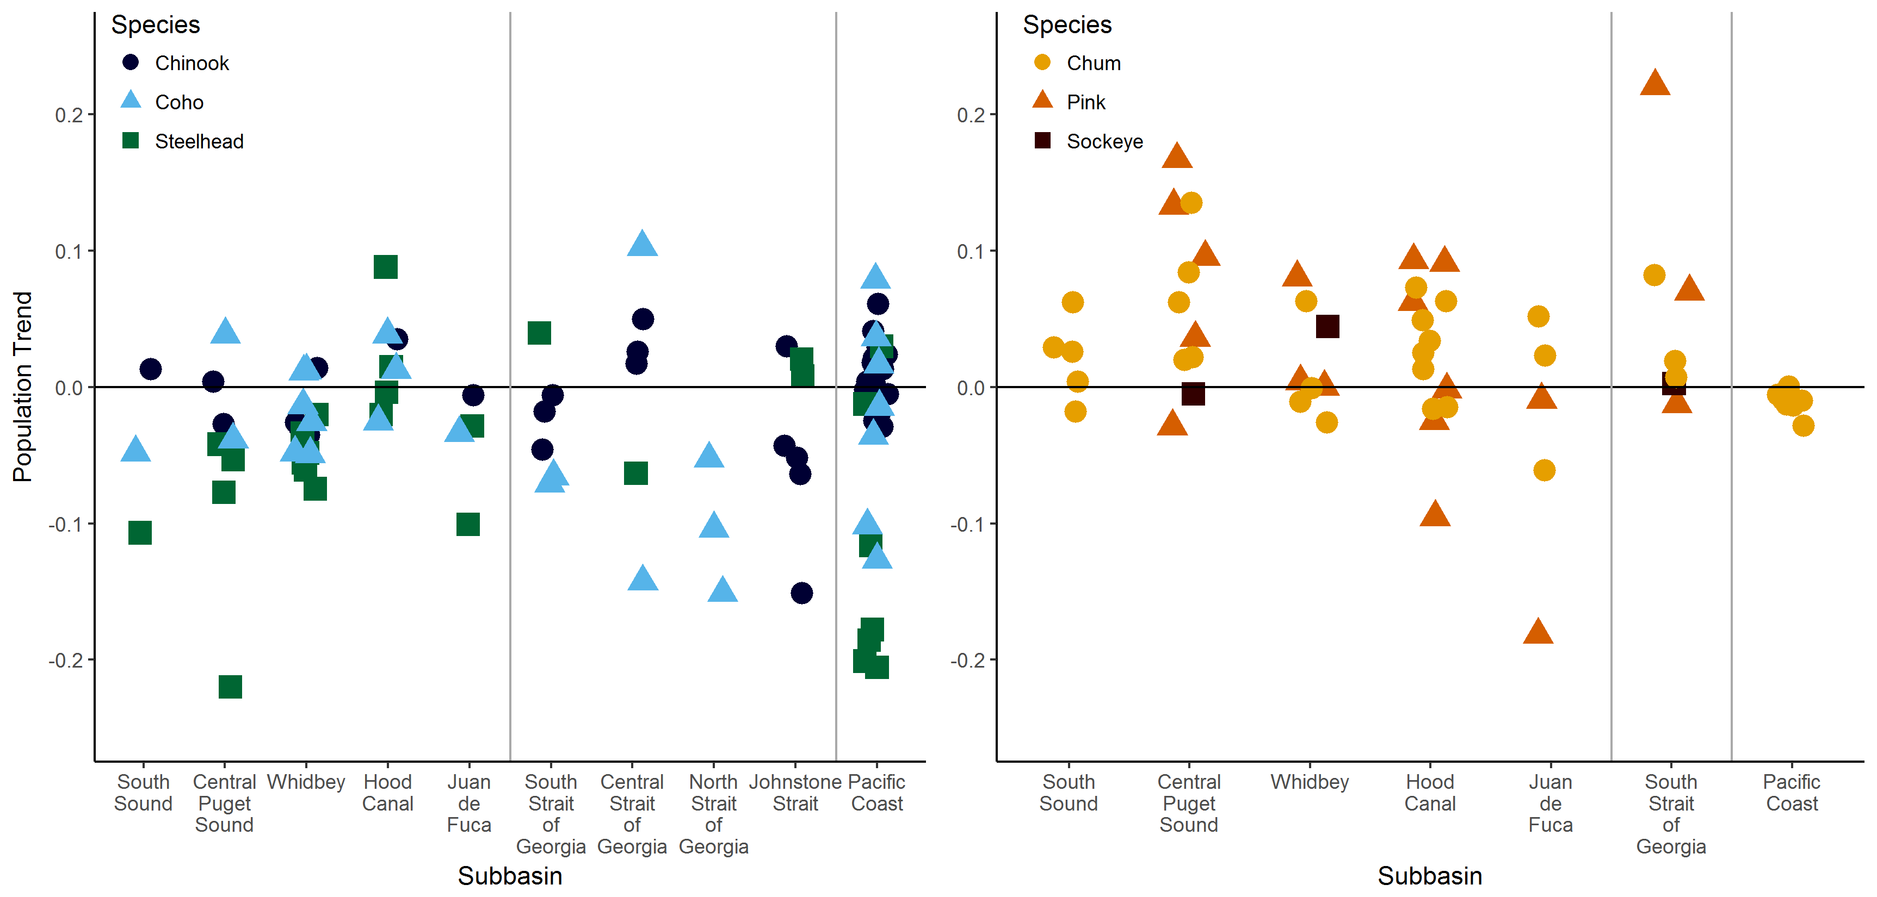

Figure 1. Salmon population trends within Puget Sound (left most subbasins), the Strait of Georgia (center subbasins) and the Pacific Coast (right) for species with generally decreasing trends (Chinook, Coho, and Steelhead, left) and increasing or stable populations trends (Chum, Pink, and Sockeye, right). Population trends were calculated using the methods of Holmes 2001 and reflect adult populations from the full extent of the available time series (typically, 1970s-present, some from 1950s). Two abnormally high Pink salmon runs were omitted from the right panel for ease of presentation—these runs had trends of 1.05 and 0.43 and were both from Puget Sound subbasins. Data are from Washington Department of Fish and Wildlife, Pacific States Marine Fisheries Commission, Ogden et al. 2015, and Zimmerman et al. 2015.

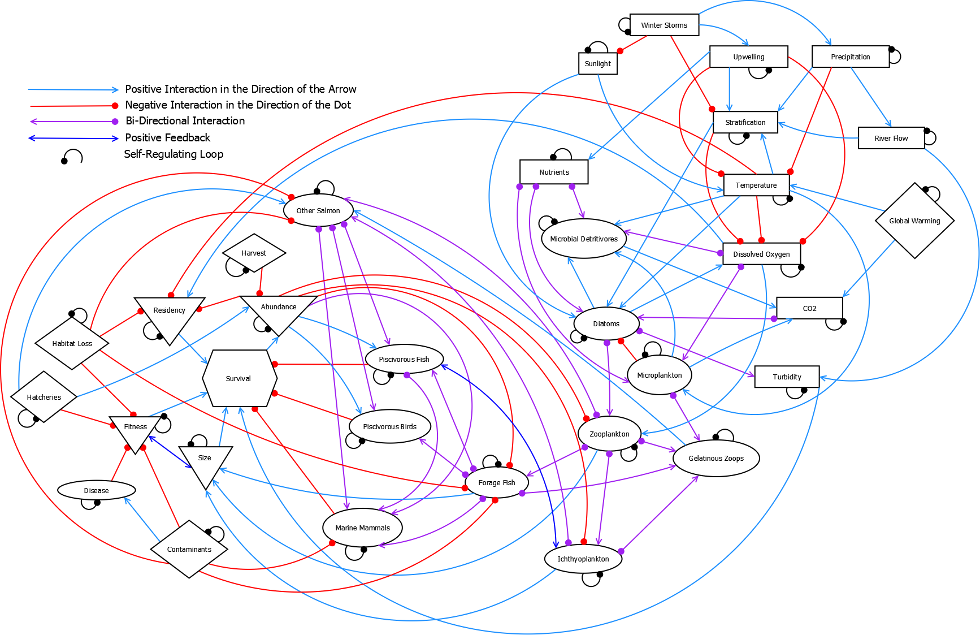

Figure 3. Conceptual directed diagram (digraph) of the Salish Sea related to survival of salmon. Model compartments (shapes) represent food web components (ovals), physical drivers (rectangles), anthropogenic impacts (diamonds) and salmon traits of interest (triangles). Survival is shown as a hexagon and was the primary variable of interest. Lines with arrows show positive relationships; lines with filled circles show negative relationships. Small negative loops on model compartments represent self-limiting functions.

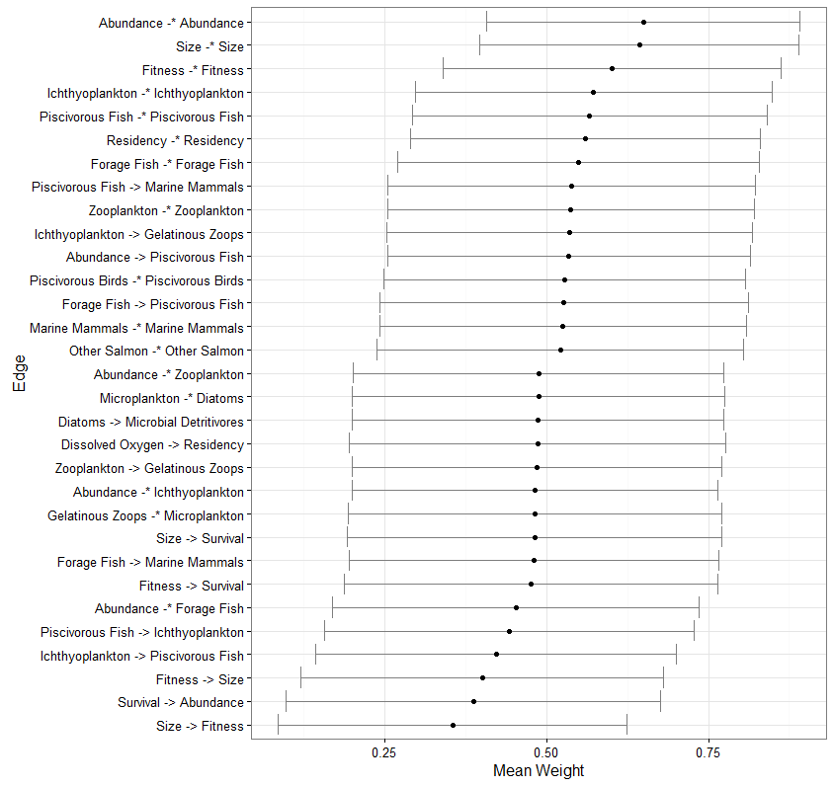

Figure 4. Calculated means and standard deviations for all model runs for edges (model linkages) with mean values different from the expected mean (0.5). The expected mean is denoted by the black dashed line. Positive linkages are indicated by an arrow and negative linkages are indicated by a dash and asterisk.

Figure 5. Driver group analysis results for the response variables for each of the four groups of drivers. Perturbations were according to Table 3 and in all four figures bars represent the number of runs resulting in a decline (dark bars) or increase (light bars) in the response variable. Results are shown for the 10,000 stable models.

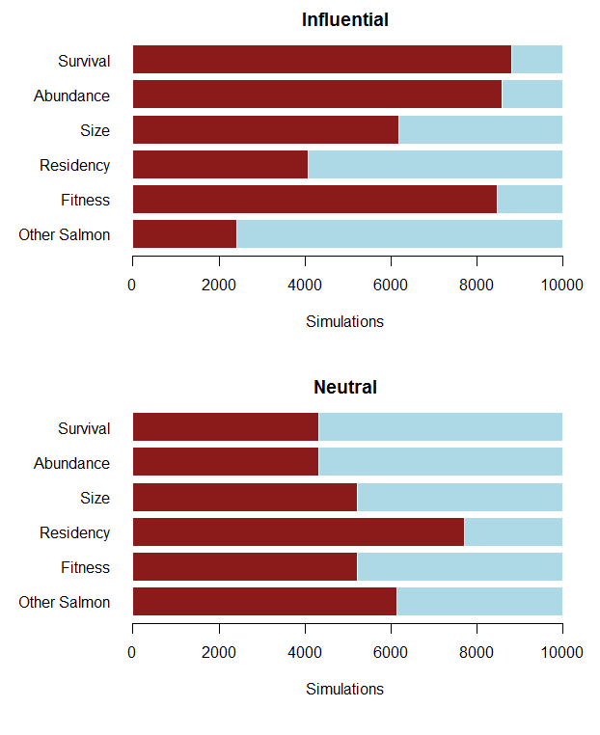

Figure 6. Comparison of multiple (n=10) strongly influential (top) and neutral (bottom) variables on salmon survival and other salmon variables. The influential variables (resulting from the analysis presented in Table 2) are: CO2, Contaminants, Diatoms, Disease, Forage Fish, Gelatinous Zooplankton, Habitat Loss, Hatcheries, Other Salmon, Temperature. The neutral variables are: Global Warming, Ichthyoplankton, Marine Mammals, Microbial Detritivores, Nutrients, Piscivorous Birds, Precipitation, Stratification, Sunlight, Zooplankton. These variables in each set were perturbed simultaneously to simulate cumulative impacts and assess model response.

Appendix 1. Methods and Data Supporting Figure 1.

Methods

To arrive at population trends, we compiled available adult run sizes for salmon in rivers throughout the Salish Sea. Data were from Pacific Fishery Management Council Stock Assessment and Fishery Evaluation (SAFE) Documents (<http://www.pcouncil.org/salmon/stock-assessment-and-fishery-evaluation-safe-documents/review-of-2015-ocean-salmon-fisheries/>), Pacific Salmon Commission Technical Committee Reports (<http://www.psc.org/publications/technical-reports/technical-committee-reports/chinook/>), Washington Department of Fish and Wildlife, Ogden et al. 2015, and Zimmerman et al. 2015. We used the longest time series available (typically from 1970s to >2010) and used the methods of Holmes (2001) to estimate a population trend and confidence interval for each run. If total run size (TRS, a total of catch and escapement or number of spawners) was not available, we used escapement/spawner (E) data.

Table A1.1 Salmon runs used in the calculation of population trends. TRS=Total Run Size, E=Escapement.

|  |  |  |  |  |  |  |  |
| --- | --- | --- | --- | --- | --- | --- | --- |
| Run | Species | Data | Years | Data Source | Subbasin | Population Trend | 95% Confidence Interval |
| Lake Washington | Chinook | TRS | 1975-2014 | PSC Joint Tech. Comm. 2016 | Central Puget Sound | 0.004 | 0.009 |
| Green | Chinook | TRS | 1975-2014 | PSC Joint Tech. Comm. 2016 | Central Puget Sound | -0.027 | 0.006 |
| Snohomish | Chinook | TRS | 1975-2014 | PSC Joint Tech. Comm. 2016 | Whidbey | -0.035 | 0.004 |
| Hood Canal | Chinook | TRS | 1981-2014 | PFMC 2016 | Hood Canal | 0.035 | 0.010 |
| Juan de Fuca | Chinook | TRS | 1981-2014 | PFMC 2016 | Juan de Fuca | -0.006 | 0.006 |
| South Puget Sound | Chinook | TRS | 1981-2014 | PFMC 2016 | South Sound | 0.013 | 0.005 |
| Nooksack | Chinook | TRS | 1981-2014 | PFMC 2016 | San Juan and Gulf Islands | -0.046 | 0.007 |
| Skagit Spring | Chinook | TRS | 1975-2014 | PSC Joint Tech. Comm. 2016 | Whidbey | 0.014 | 0.006 |
| Skagit Summer/fall | Chinook | TRS | 1975-2014 | PSC Joint Tech. Comm. 2016 | Whidbey | -0.026 | 0.005 |
| Stillaguamish | Chinook | TRS | 1975-2014 | PSC Joint Tech. Comm. 2016 | Whidbey | -0.030 | 0.011 |
| Willapa | Chinook | TRS | 1976-2014 | PFMC 2016 | Pacific Coast | 0.021 | 0.007 |
| Grays Harbor Spring/Summer | Chinook | TRS | 1976-2014 | PFMC 2016 | Pacific Coast | 0.018 | 0.005 |
| Grays Harbor Fall | Chinook | TRS | 1975-2014 | PSC Joint Tech. Comm. 2016 | Pacific Coast | 0.013 | 0.005 |
| Queets Spr/Summer | Chinook | TRS | 1976-2015 | PSC Joint Tech. Comm. 2016 | Pacific Coast | -0.025 | 0.007 |
| Queets fall | Chinook | TRS | 1976-2014 | PSC Joint Tech. Comm. 2016 | Pacific Coast | 0.002 | 0.004 |
| Hoh Spring/Summer | Chinook | TRS | 1976-2015 | PSC Joint Tech. Comm. 2016 | Pacific Coast | -0.019 | 0.006 |
| Hoh fall | Chinook | TRS | 1976-2015 | PSC Joint Tech. Comm. 2016 | Pacific Coast | -0.002 | 0.004 |
| Quillayute spring/summer | Chinook | TRS | 1976-2015 | PSC Joint Tech. Comm. 2016 | Pacific Coast | -0.029 | 0.005 |
| Quillayute fall | Chinook | TRS | 1976-2015 | PFMC 2016 | Pacific Coast | -0.005 | 0.005 |
| Hoko fall term | Chinook | TRS | 1986-2015 | PSC Joint Tech. Comm. 2016 | Pacific Coast | 0.021 | 0.009 |
| Fraser Spring/summer | Chinook | TRS | 1975-2015 | PSC Joint Tech. Comm. 2016 | Central Strait of Georgia | 0.017 | 0.002 |
| Harrison | Chinook | TRS | 1984-2015 | PSC Joint Tech. Comm. 2016 | Central Strait of Georgia | 0.050 | 0.004 |
| Lake Shuswap | Chinook | E | 1975-2015 | PSC Joint Tech. Comm. 2016 | Central Strait of Georgia | 0.026 | 0.006 |
| Nanaimo | Chinook | E | 1975-2015 | PSC Joint Tech. Comm. 2016 | South Strait of Georgia, San Juan and Gulf Islands | -0.018 | 0.007 |
| Cowichan | Chinook | E | 1975-2015 | PSC Joint Tech. Comm. 2016 | South Strait of Georgia, San Juan and Gulf Islands | -0.006 | 0.007 |
| Nimpkish | Chinook | E | 1975-2015 | PSC Joint Tech. Comm. 2016 | Johnstone Strait | -0.052 | 0.015 |
| Klinaklini | Chinook | E | 1975-2015 | PSC Joint Tech. Comm. 2016 | Johnstone Strait | 0.030 | 0.009 |
| Kakweiken | Chinook | E | 1975-2015 | PSC Joint Tech. Comm. 2016 | Johnstone Strait | -0.043 | 0.011 |
| Kingcome | Chinook | E | 1975-2015 | PSC Joint Tech. Comm. 2016 | Johnstone Strait | -0.064 | 0.018 |
| Wakeman | Chinook | E | 1975-2015 | PSC Joint Tech. Comm. 2016 | Johnstone Strait | -0.151 | 0.028 |
| Marble | Chinook | E | 1975-2015 | PSC Joint Tech. Comm. 2016 | Pacific Coast | 0.013 | 0.005 |
| Burman | Chinook | E | 1975-2015 | PSC Joint Tech. Comm. 2016 | Pacific Coast | 0.061 | 0.012 |
| Tahsis | Chinook | E | 1975-2015 | PSC Joint Tech. Comm. 2016 | Pacific Coast | 0.024 | 0.014 |
| Artlish | Chinook | E | 1975-2015 | PSC Joint Tech. Comm. 2016 | Pacific Coast | 0.029 | 0.016 |
| Kaouk | Chinook | E | 1975-2015 | PSC Joint Tech. Comm. 2016 | Pacific Coast | 0.041 | 0.026 |
| Tahsish | Chinook | E | 1975-2015 | PSC Joint Tech. Comm. 2016 | Pacific Coast | 0.004 | 0.011 |
| Cedar River Winter | Steelhead | TRS | 1987-2013 | N. Kendall, WDFW pers. comm | Central Puget Sound | -0.220 | 0.023 |
| Green River Winter | Steelhead | TRS | 1978-2013 | N. Kendall, WDFW pers. comm | Central Puget Sound | -0.053 | 0.004 |
| Puyallup/Carbon Winter | Steelhead | TRS | 1983-2013 | N. Kendall, WDFW pers. comm comm | Central Puget Sound | -0.077 | 0.006 |
| White River (Puyallup) Winter | Steelhead | TRS | 1986-2013 | N. Kendall, WDFW pers. comm | Central Puget Sound | -0.042 | 0.008 |
| Englishman River winter | Steelhead | E | 1982-2015 | K. Pellett, pers. comm | Central Strait of Georgia | -0.063 | 0.011 |
| East Hood Canal Winter | Steelhead | TRS | 1989-2013 | N. Kendall, WDFW pers. comm | Hood Canal | 0.088 | 0.016 |
| Skokomish Winter | Steelhead | TRS | 1985-2006 | N. Kendall, WDFW pers. comm | Hood Canal | -0.020 | 0.013 |
| South Hood Canal Winter | Steelhead | TRS | 1988-2013 | N. Kendall, WDFW pers. comm | Hood Canal | -0.004 | 0.009 |
| West Hood Canal Winter | Steelhead | TRS | 2003-2013 | N. Kendall, WDFW pers. comm | Hood Canal | 0.015 | 0.021 |
| Tsitika River summer | Steelhead | E | 1976-2015 | K. Pellett, pers. comm | Johnstone Strait | 0.008 | 0.007 |
| Salmon River winter | Steelhead | TRS | 1981-2015 | N. Kendall, WDFW pers. comm | Johnstone Strait | 0.021 | 0.036 |
| Sequim and Discovery Bays Tributaries Winter | Steelhead | TRS | 1987-2013 | N. Kendall, WDFW pers. comm | Juan de Fuca | -0.101 | 0.100 |
| Strait of Juan de Fuca Independent Tributaries Winter | Steelhead | TRS | 1991-2009 | N. Kendall, WDFW pers. comm | Juan de Fuca | -0.028 | 0.022 |
| Glendale winter | Steelhead | E | 1992-2014 | K. Pellett, pers. comm | Pacific Coast | -0.178 | 0.085 |
| Ahnuhati winter | Steelhead | E | 1992-2014 | K. Pellett, pers. comm | Pacific Coast | -0.186 | 0.065 |
| Kakweiken winter | Steelhead | E | 1992-2014 | K. Pellett, pers. comm | Pacific Coast | -0.206 | 0.063 |
| Atwaykellesse winter | Steelhead | E | 1992-2014 | K. Pellett, pers. comm | Pacific Coast | -0.116 | 0.062 |
| Wahpeeto winter | Steelhead | E | 1992-2014 | K. Pellett, pers. comm | Pacific Coast | -0.201 | 0.066 |
| Heber River summer | Steelhead | E | 1975-2015 | K. Pellett, pers. comm | Pacific Coast | -0.012 | 0.004 |
| Gordon River summer | Steelhead | E | 1998-2015 | K. Pellett, pers. comm | Pacific Coast | 0.030 | 0.042 |
| Nisqually Winter | Steelhead | TRS | 1980-2013 | N. Kendall, WDFW pers. comm | South Sound | -0.107 | 0.016 |
| Samish Winter | Steelhead | TRS | 1979-2013 | N. Kendall, WDFW pers. comm | South Strait of Georgia | 0.039 | 0.011 |
| Pilchuck Winter | Steelhead | E | 1981-2014 | N. Kendall, WDFW pers. comm | Whidbey | -0.020 | 0.009 |
| Skagit River Summer and Winter | Steelhead | TRS | 1978-2013 | N. Kendall, WDFW pers. comm | Whidbey | -0.034 | 0.007 |
| Snohomish System Winter | Steelhead | TRS | 1987-2013 | N. Kendall, WDFW pers. comm | Whidbey | -0.048 | 0.012 |
| Snohomish/Skykomish Winter | Steelhead | TRS | 1987-2013 | N. Kendall, WDFW pers. comm | Whidbey | -0.061 | 0.010 |
| Snoqualmie Winter | Steelhead | TRS | 1987-2013 | N. Kendall, WDFW pers. comm | Whidbey | -0.056 | 0.008 |
| Stillaguamish Winter | Steelhead | TRS | 1987-2013 | N. Kendall, WDFW pers. comm | Whidbey | -0.075 | 0.022 |
| Green | Coho | TRS | 1973-2010 | Zimmerman et al. 2015 | Central Puget Sound | 0.039 | 0.014 |
| Puyallup | Coho | TRS | 1974-2010 | Zimmerman et al. 2015 | Central Puget Sound | -0.038 | 0.008 |
| Big Qualicum | Coho | TRS | 1973-2010 | Zimmerman et al. 2015 | Central Strait of Georgia | -0.143 | 0.011 |
| Inch | Coho | TRS | 1984-2010 | Zimmerman et al. 2015 | Central Strait of Georgia | 0.103 | 0.023 |
| Big Beef Creek | Coho | TRS | 1977-2010 | Zimmerman et al. 2015 | Hood Canal | -0.025 | 0.009 |
| Quilcene | Coho | TRS | 1979-2010 | Zimmerman et al. 2015 | Hood Canal | 0.039 | 0.014 |
| Skokomish | Coho | TRS | 1973-2010 | Zimmerman et al. 2015 | Hood Canal | 0.013 | 0.008 |
| Straits | Coho | TRS | 1985-2010 | Zimmerman et al. 2015 | Juan de Fuca | -0.034 | 0.012 |
| Black | Coho | TRS | 1978-2010 | Zimmerman et al. 2015 | North Strait of Georgia | -0.052 | 0.021 |
| Puntledge | Coho | TRS | 1974-2010 | Zimmerman et al. 2015 | North Strait of Georgia | -0.151 | 0.020 |
| Quinsam | Coho | TRS | 1978-2004 | Zimmerman et al. 2015 | North Strait of Georgia | -0.104 | 0.010 |
| Bingham Creek | Coho | TRS | 1976-2010 | Zimmerman et al. 2015 | Pacific Coast | 0.017 | 0.014 |
| Cowlitz | Coho | TRS | 1982-2010 | Zimmerman et al. 2015 | Pacific Coast | -0.126 | 0.030 |
| Grays | Coho | TRS | 1982-2010 | Zimmerman et al. 2015 | Pacific Coast | -0.036 | 0.009 |
| Quinault | Coho | TRS | 1977-2010 | Zimmerman et al. 2015 | Pacific Coast | 0.079 | 0.015 |
| Robertson | Coho | TRS | 1975-2010 | Zimmerman et al. 2015 | Pacific Coast | -0.014 | 0.013 |
| Satsop | Coho | TRS | 1973-2010 | Zimmerman et al. 2015 | Pacific Coast | 0.036 | 0.010 |
| Washougal | Coho | TRS | 1976-2010 | Zimmerman et al. 2015 | Pacific Coast | -0.102 | 0.023 |
| Deschutes | Coho | TRS | 1977-2008 | Zimmerman et al. 2015 | South Sound | -0.048 | 0.041 |
| Chilliwack | Coho | TRS | 1982-2004 | Zimmerman et al. 2015 | South Strait of Georgia | -0.066 | 0.060 |
| Nooksack | Coho | TRS | 1976-2009 | Zimmerman et al. 2015 | South Strait of Georgia | -0.071 | 0.028 |
| Skagit | Coho | TRS | 1991-2010 | Zimmerman et al. 2015 | Whidbey | -0.049 | 0.014 |
| Stilliguamish | Coho | TRS | 1981-2014 | Zimmerman et al. 2015 | Whidbey | -0.013 | 0.013 |
| Snohomish | Coho | TRS | 1981-2014 | Zimmerman et al. 2015 | Whidbey | -0.026 | 0.010 |
| Baker | Coho | TRS | 1983-2010 | Zimmerman et al. 2015 | Whidbey | -0.048 | 0.018 |
| Skykomish | Coho | TRS | 1978-2010 | Zimmerman et al. 2015 | Whidbey | 0.012 | 0.010 |
| Tulalip Bay | Coho | TRS | 1974-2010 | Zimmerman et al. 2015 | Whidbey | 0.011 | 0.017 |
| Green River (Area 10A) | Pink | TRS | 2001-2013 | A. Dufault, WDFW, pers. comm. | Central Puget Sound | 1.053 | 0.364 |
| Puyallup River (Area 11A) | Pink | TRS | 1959-2013 | A. Dufault, WDFW, pers. comm. | Central Puget Sound | 0.133 | 0.038 |
| Chambers | Pink | TRS | 1959-2013 | A. Dufault, WDFW, pers. comm. | Central Puget Sound | 0.096 | 0.206 |
| Nisqually R. Drainage | Pink | TRS | 1959-2013 | A. Dufault, WDFW, pers. comm. | Central Puget Sound | 0.167 | 0.088 |
| Area 13A streams | Pink | TRS | 1959-2013 | A. Dufault, WDFW, pers. comm. | Central Puget Sound | -0.029 | 0.054 |
| Area 13B streams | Pink | TRS | 1959-2013 | A. Dufault, WDFW, pers. comm. | Central Puget Sound | 0.036 | 0.035 |
| Port Gamble | Pink | TRS | 1959-2013 | A. Dufault, WDFW, pers. comm. | Hood Canal | 0.425 | 0.593 |
| Dosewallips | Pink | TRS | 1959-2013 | A. Dufault, WDFW, pers. comm. | Hood Canal | -0.095 | 0.028 |
| Duckabush | Pink | TRS | 1959-2013 | A. Dufault, WDFW, pers. comm. | Hood Canal | -0.025 | 0.054 |
| Hamma | Pink | TRS | 1959-2013 | A. Dufault, WDFW, pers. comm. | Hood Canal | 0.091 | 0.052 |
| Hoodsport Hatchery | Pink | TRS | 1959-2013 | A. Dufault, WDFW, pers. comm. | Hood Canal | 0.063 | 0.024 |
| Misc 12C | Pink | TRS | 1959-2013 | A. Dufault, WDFW, pers. comm. | Hood Canal | -0.002 | 0.041 |
| Skokomish R. Drainage | Pink | TRS | 1959-2013 | A. Dufault, WDFW, pers. comm. | Hood Canal | 0.093 | 0.055 |
| Dungeness River | Pink | TRS | 1959-2013 | A. Dufault, WDFW, pers. comm. | Juan de Fuca | -0.009 | 0.053 |
| Elwha River | Pink | TRS | 1959-2013 | A. Dufault, WDFW, pers. comm. | Juan de Fuca | -0.182 | 0.093 |
| Nooksack River | Pink | TRS | 1959-2013 | A. Dufault, WDFW, pers. comm. | South Strait of Georgia | -0.012 | 0.035 |
| Samish River | Pink | TRS | 1959-2013 | A. Dufault, WDFW, pers. comm. | South Strait of Georgia | 0.221 | 0.068 |
| Fraser | Pink | TRS | 1959-2011 | Ogden et al. 2015 | South Strait of Georgia | 0.070 | 0.030 |
| Skagit River | Pink | TRS | 1959-2013 | A. Dufault, WDFW, pers. comm. | Whidbey | 0.004 | 0.030 |
| Snohomish River | Pink | TRS | 1959-2013 | A. Dufault, WDFW, pers. comm. | Whidbey | 0.080 | 0.025 |
| Stillaguamish River | Pink | TRS | 1959-2013 | A. Dufault, WDFW, pers. comm. | Whidbey | 0.000 | 0.027 |
| Lake Washington | Sockeye | E | 1972-2015 | A. Dufault, WDFW, pers. comm. | Central Puget Sound | -0.005 | 0.006 |
| Fraser | Sockeye | TRS | 1960-2012 | Ogden et al. 2015 | South Strait of Georgia | 0.003 | 0.004 |
| Baker Lake | Sockeye | E | 1970-2015 | A. Dufault, WDFW, pers. comm | Whidbey | 0.044 | 0.012 |
| Misc 10 -Seattle | Chum | TRS | 1968-2009 | A. Dufault, WDFW, pers. comm | Central Puget Sound | 0.084 | 0.009 |
| Green-Duwamish River | Chum | TRS | 1968-2009 | A. Dufault, WDFW, pers. comm | Central Puget Sound | 0.135 | 0.014 |
| Misc 10e -Port Orchard | Chum | TRS | 1968-2009 | A. Dufault, WDFW, pers. comm | Central Puget Sound | 0.022 | 0.007 |
| Misc 11 -Tacoma | Chum | TRS | 1968-2009 | A. Dufault, WDFW, pers. comm | Central Puget Sound | 0.020 | 0.006 |
| Puyallup River | Chum | TRS | 1968-2009 | A. Dufault, WDFW, pers. comm | Central Puget Sound | 0.062 | 0.012 |
| Port Gamble Pens (9a) | Chum | TRS | 1968-2009 | A. Dufault, WDFW, pers. comm | Hood Canal | -0.016 | 0.009 |
| N. Hood Canal (12) | Chum | TRS | 1968-2009 | A. Dufault, WDFW, pers. comm | Hood Canal | -0.015 | 0.008 |
| Misc 12b -Hood Canal | Chum | TRS | 1968-2009 | A. Dufault, WDFW, pers. comm | Hood Canal | 0.013 | 0.007 |
| Quilcene River (12a) | Chum | TRS | 1968-2009 | A. Dufault, WDFW, pers. comm | Hood Canal | 0.034 | 0.011 |
| Misc 12c -Hood Canal | Chum | TRS | 1968-2009 | A. Dufault, WDFW, pers. comm | Hood Canal | 0.063 | 0.006 |
| Hoodsport Hatchery | Chum | TRS | 1968-2009 | A. Dufault, WDFW, pers. comm | Hood Canal | 0.049 | 0.010 |
| Skokomish River | Chum | TRS | 1968-2009 | A. Dufault, WDFW, pers. comm | Hood Canal | 0.073 | 0.007 |
| Misc 12d -Hood Canal | Chum | TRS | 1968-2009 | A. Dufault, WDFW, pers. comm | Hood Canal | 0.025 | 0.007 |
| Dungeness River | Chum | TRS | 1968-2009 | A. Dufault, WDFW, pers. comm | Juan de Fuca | 0.052 | 0.012 |
| Elwha River | Chum | TRS | 1968-2009 | A. Dufault, WDFW, pers. comm | Juan de Fuca | -0.061 | 0.014 |
| Misc Strait Streams | Chum | TRS | 1968-2009 | A. Dufault, WDFW, pers. comm | Juan de Fuca | 0.023 | 0.009 |
| Grays Harbor Wild Runsize | Chum | TRS | 1968-2009 | A. Dufault, WDFW, pers. comm | Pacific Coast | -0.006 | 0.006 |
| Willapa Bay Wild And Hatchery Escapement And Total Runsize | Chum | TRS | 1980-1999 | A. Dufault, WDFW, pers. comm | Pacific Coast | -0.010 | 0.006 |
| Inside South Coast (Non-Fraser) | Chum | TRS | 1953-2012 | Ogden et al. 2015 | Pacific Coast | 0.000 | 0.005 |
| Hecate Lowlands | Chum | E | 1954-2012 | Ogden et al. 2015 | Pacific Coast | -0.014 | 0.004 |
| North Haida Gwaii | Chum | E | 1954-2012 | Ogden et al. 2015 | Pacific Coast | -0.028 | 0.009 |
| Portland Inlet | Chum | E | 1954-2012 | Ogden et al. 2015 | Pacific Coast | -0.006 | 0.005 |
| Rivers Inlet | Chum | E | 1954-2012 | Ogden et al. 2015 | Pacific Coast | -0.009 | 0.014 |
| Skidegate | Chum | E | 1954-2012 | Ogden et al. 2015 | Pacific Coast | -0.013 | 0.006 |
| Misc 13 -South Puget Sound | Chum | TRS | 1968-2009 | A. Dufault, WDFW, pers. comm | South Sound | -0.018 | 0.050 |
| Chambers Creek | Chum | TRS | 1968-2009 | A. Dufault, WDFW, pers. comm | South Sound | 0.004 | 0.032 |
| Nisqually River | Chum | TRS | 1968-2009 | A. Dufault, WDFW, pers. comm | South Sound | 0.026 | 0.054 |
| Misc 13a -Minter Creek | Chum | TRS | 1968-2009 | A. Dufault, WDFW, pers. comm | South Sound | 0.062 | 0.008 |
| Misc 13b -Olympia | Chum | TRS | 1968-2009 | A. Dufault, WDFW, pers. comm | South Sound | 0.029 | 0.003 |
| Nooksack River | Chum | TRS | 1968-2009 | A. Dufault, WDFW, pers. comm | South Strait of Georgia | 0.019 | 0.005 |
| Samish River | Chum | TRS | 1968-2009 | A. Dufault, WDFW, pers. comm | South Strait of Georgia | 0.007 | 0.010 |
| Misc 7b Streams | Chum | TRS | 1968-2009 | A. Dufault, WDFW, pers. comm | South Strait of Georgia | 0.082 | 0.011 |
| Skagit River | Chum | TRS | 1968-2009 | A. Dufault, WDFW, pers. comm | Whidbey | -0.026 | 0.006 |
| Tulalip Tribe | Chum | TRS | 1968-2009 | A. Dufault, WDFW, pers. comm | Whidbey | 0.063 | 0.013 |
| Snohomish River | Chum | TRS | 1968-2009 | A. Dufault, WDFW, pers. comm | Whidbey | -0.001 | 0.011 |
| Stillaguamish River | Chum | TRS | 1968-2009 | A. Dufault, WDFW, pers. comm | Whidbey | -0.011 | 0.008 |

Appendix 2. Model Perturbations and References

|  |  |  |  |
| --- | --- | --- | --- |
| **Drivers** | **Variables** | **Reference** | **Invoked Perturbation** |
| *Environmental* | Sunlight | Littell et al. 2009 | ↑ |
|  | Winter Storms | Littell et al. 2009 | ↑ |
|  | Precipitation | Mauger et al. 2015, Littell et al. 2009 | ↑ |
|  | Upwelling[1] | Mauger et al. 2015 | ↓ |
|  | Stratification[2] | Mauger et al. 2015 | ↑ |
|  | Temperature | Littell et al. 2009, Field et al. 2006, Hollowed et al. 2001 | ↑ |
|  | River Flow | Littell et al. 2009[3] | ↑ |
|  | Turbidity | PSEMP 2016, WADOE 2017 | ↓ |
|  | Dissolved Oxygen | Roberts et al. 2014 | ↓ |
| *Production* | Nutrients | Roberts et al. 2014 | ↑ |
|  | Microplankton | Moore et al. 2015 | ↑ |
|  | Microbial Detritivores | PSEMP 2016 | ↑ |
|  | Diatoms | Brandenberger 2008, WADOE 2017 | ↓ |
| *Food web* | Zooplankton[4] | Li et al. 2013 | ↓ |
|  | Gelatinous Zooplankton | Greene et al. 2015 | ↑ |
|  | Forage Fish | Greene et al. 2015 | ↓ |
|  | Ichthyoplankton | Palsson et al. 1998 | ↓ |
|  | Other Salmon | PFMC 2016, Figure 1 | ↑ |
|  | Piscivorous Fish | Palsson et al. 1998 | ↓ |
|  | Piscivorous Birds | Gaydos and Pearson 2011, Anderson et al. 2009 | ↓ |
|  | Marine Mammals | Chasco et al. 2017 | ↑ |
| *Anthropogenic* | Hatcheries | Christie et al. 2012, Waples 1999 | ↑ |
|  | Harvest[5] |  | ↑ |
|  | Habitat Loss | Puget Sound Water Quality Action Team 2002 | ↑ |
|  | CO2 | Feely et al. 2010 | ↑ |
|  | Global Warming | IPCC 2014 | ↑ |
|  | Contaminants | O’Neill et al. 2009, Meador et al. 2006, Crecelius et al. 1995 | ↑ |
|  | Disease | SSMSP Hypotheses | ↑ |

Literature Cited

Anderson, E.M., Bower, J.L., Nysewander, D.R., Evenson, J.R. and Lovvorn, J.R.  2009.  Changes in avifaunal abundance in a heavily-used wintering and migration site in Puget Sound, Washington during 1966–2007. *Marine Ornithology* 37: 19-27.

Burke, B. J., B. R. Beckman, W. T. Peterson, C. Morgan, E. A. Daly, M. Litz. 2013. Multivariate methods to forecast Pacific salmon returns. *PLoS ONE* 8(1): e54134.

Chasco, B. I. Kaplan, A. Thomas, A. Alejandro-Gutiérrez, D.P. Noren, M.J. Ford, M.B. Hanson, J. Scordino, S.J. Jeffries, S.F. Pearson, K. Marshall, E.J. Ward. 2017. Estimates of Chinook salmon consumption in Washington State inland water by four marine mammal predators from 1970-2015. *Can. J. of Fish. and Aqua. Sci. 10.1139/cjfas-2016-0203*

Christie, M.R., M.L. Marine, R.A. French, R.S. Waples and M.S. Blouin. 2012. Effective size of a wild salmonid population is greatly reduced by hatchery supplementation. *Heredity* 109: 254-260.

Crecilius, E.A., V.I. Cullinan, L.F. Lefkovitz and C. Peden. 1995. Historical trends in the accumulation of chemicals in Puget Sound. 825-831, in Volume 2, Puget Sound Research '95 Proceedings, Puget Sound Water Quality Authority, Olympia.

Feely, R. A., S. R. Alin, J. Newton, C. L. Sabine, M. Warner, A. Devol, C. Krembs, and C. Maloy. 2010. The combined effects of ocean acidification, mixing, and respiration on pH and carbonate saturation in an urbanized estuary. *Estuarine, Coastal and Shelf Science*, 88, 442-449, doi:10.1016/j.ecss.2010.05.004

Field, D., D. Cayan, and F. Chavez. 2006. Secular warming in the California current and North Pacific. *California Cooperative Oceanic Fisheries Investigations Reports*, 47, 92-108.

Hoekstra, J. M., K.K. Bartz, M.H. Ruckelshaus, J.M. Moslemi, and T.K. Harms. 2007. Quantitative threat analysis for management of an imperiled species: Chinook salmon (*Oncorhynchus tshawytscha*). *Ecological Applications*, 17: 2061-2073.

Hollowed, A. B., S. R. Hare, and W. S. Wooster. 2001. Pacific Basin climate variability and patterns of Northeast Pacific marine fish production. *Progress in Oceanography*, 49, 257-282, doi:10.1016/S0079-6611(01)00026-X.

Gaydos, J.K. and S.F. Pearson. 2011. Birds and mammals that depend on the Salish Sea: A compilation. *Northwest Naturalist*: 92:79–94.

Intergovernmental Panel on Climate Change. 2014. Climate Change 2014: Synthesis Report. Contribution of Working Groups I, II and III to the Fifth Assessment Report of the Intergovernmental Panel on Climate Change [Core Writing Team, R.K. Pachauri and L.A. Meyer (eds.)]. IPCC, Geneva, Switzerland, 151 pp.

Li, L., D. Mackas, B. Hunt, J. Schweigert, E. Pakhomov, I. Perry, M. Galbraith, T.J. Pitcher. 2013. Zooplankton communities in the Strait of Georgia, British Columbia, track large-scale climate forcing over the Pacific Ocean. *Progress in Oceanography*. doi:http://dx.doi.org/10.1016/j.pocean.2013.05.025

Littell, J.S., M. McGuire Elsner, L.C. Whitely Binder, and A.K. Snover (eds). 2009. *The Washington Climate Change Impacts Assessment: Evaluating Washington's Future in a Changing Climate.* Climate Impacts Group, University of Washington, Seattle, Washington. Available at: [www.cses.washington.edu/db/pdf/wacciaexecsummary638.pdf](http://www.cses.washington.edu/db/pdf/wacciaexecsummary638.pdf)

Mauger, G.S., J.H. Casola, H.A. Morgan, R.L. Strauch, B. Jones, B. Curry, T.M. Busch Isaksen, L. Whitely Binder, M.B. Krosby, and A.K. Snover. 2015. State of Knowledge: Climate Change in Puget Sound. Report prepared for the Puget Sound Partnership and the National Oceanic and Atmospheric Administration. Climate Impacts Group, University of Washington, Seattle. doi:10.7915/CIG93777D

Meador, J.P., F.C. Sommers, G.M. Ylitalo, C.A. Sloan. 2006. Altered growth and related physiological response in juvenile Chinook salmon (*Oncorhynchus tshawytscha*) from dietary exposure to polycyclic aromatic hydrocarbons (PAHs). *Can. J. of Fish. and Aqua. Sci.* 63: 2364-2376.

Moore, S.K. et al., 2011. Past trends and future scenarios for environmental conditions favoring the accumulation of paralytic shellfish toxins in Puget Sound shellfish. *Harmful Algae*, 10, 521-529.

Moore, S.K. et al., 2015. Present-day and future climate pathways affecting the harmful algal blooms species *Alexandrium catenella* in Puget Sound, WA, USA. *Harmful Algae*, 48, 1-11. 25

O'Neill, S.M., and West, J.E. 2009. Marine Distribution, Life History Traits, and the Accumulation of Polychlorinated Biphenyls in Chinook Salmon from Puget Sound, Washington*. Transactions of the American Fisheries Society* 138(3): 616-632.

Pacific Fishery Management Council. 2016. Review of 2015 Ocean Salmon Fisheries: Stock Assessment and Fishery Evaluation Document for the Pacific Coast Salmon Fishery Management Plan. Pacific Fishery Management Council, Portland, Oregon. http://www.pcouncil.org/wp-content/uploads/2016/02/Review_of_2015_Salmon_Fisheries_FullDocument.pdf

Palsson, W.A., T.J. Northrup, and M.W. Baker. 1998. Puget Sound Groundfish Management Plan. Washington Department of Fish and Wildlife. Olympia, WA.

PSEMP Marine Waters Workgroup. 2016. Puget Sound marine waters: 2015 overview. S. K. Moore, R. Wold, K. Stark, J. Bos, P. Williams, K. Dzinbal, C. Krembs and J. Newton (Eds). URL: www.psp.wa.gov/PSEMP/PSmarinewatersoverview.php.

Puget Sound Water Quality Action Team. 2002. *2002 Puget Sound Update: Eighth Annual Report of the Puget Sound Ambient Monitoring Program*. Puget Sound Water Quality Action Team. Olympia, Washington.

Roberts, M., T. Mohamedali, B. Sackmann, T. Khangaonkar, W. Long. 2014. Puget Sound and the Straits Dissolved Oxygen Assessment Impacts of Current and Future Human Nitrogen Sources and Climate Change through 2070. Washington State Department of Ecology, Publication No. 14-03-007. Olympia, WA.

Waples, R.S. 1999. Dispelling some myths about hatcheries. *Fisheries* 24: 12–21.

WADOE. 2017. Marine Waters Program, Washington Department of Ecology. http://www.ecy.wa.gov/programs/eap/mar_wat/

Appendix 3. Model Output for Individual Perturbations

Model output showing 6 model nodes of interest: Salmon Survival, Salmon Abundance, Salmon Size, Residency, Fitness and Other Salmon. Other Salmon refers to the populations (chum, pink, and sockeye) which have not seen a noticeable decline in survival in recent decades. In each plot box, the model node that was perturbed is shown in the title, with the direction of the press (Increase or Decrease) shown below. The bar graphs indicate the proportion of model simulations with negative (red bars) and positive (blue bars) outcomes for that model node, given the invoked press perturbation. Where the bars are dark gray, there was no impact to those nodes.

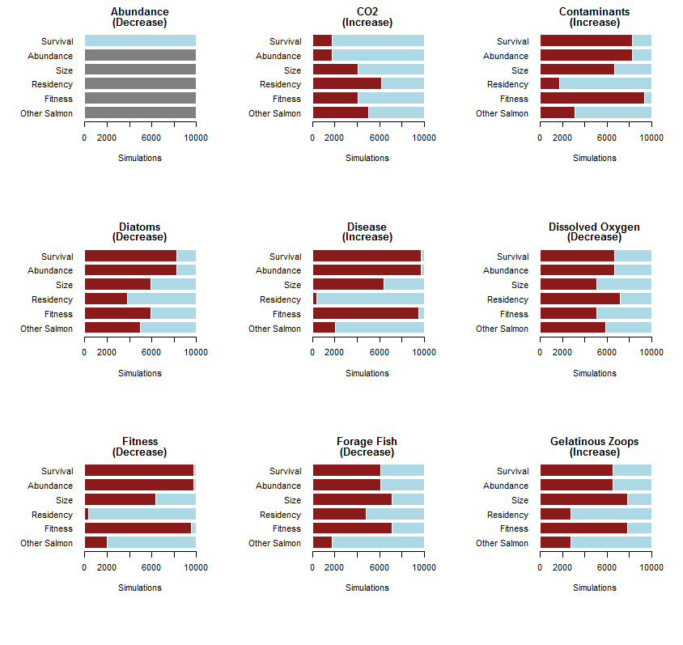

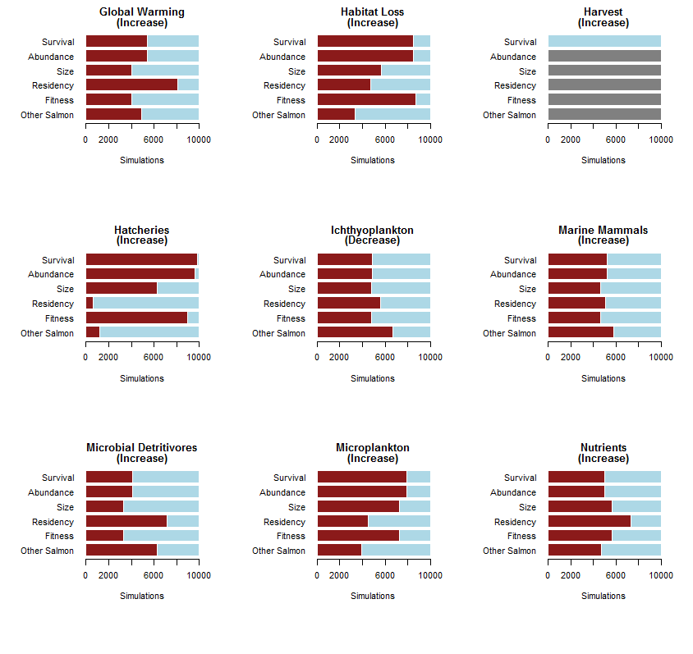

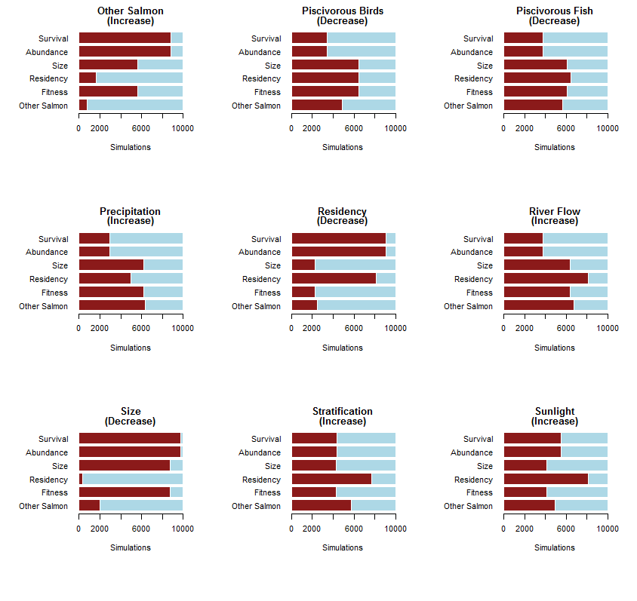

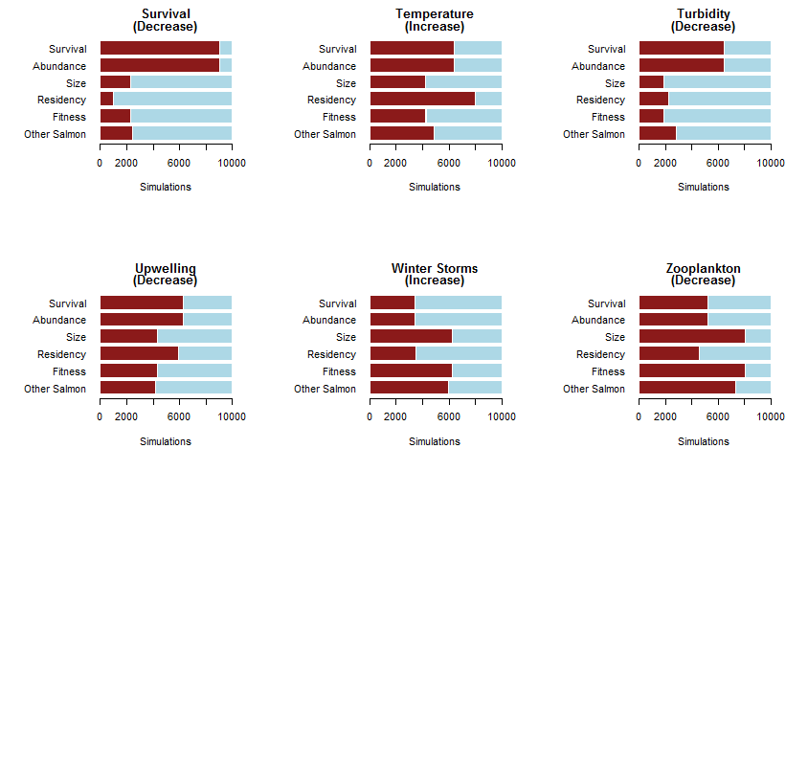

1. While impacts to upwelling are unknown, we invoked a decrease in upwelling because it would reduce the delivery of nutrients to Puget Sound and potentially disrupt primary production.
2. Decreased mixing as a result of changes in freshwater flow could lead to increased stratification; while the exact response is unknown (see Mauger et al. 2015), we have invoked an increase in stratification because decreased mixing would likely lead to declines in primary productivity.
3. River flow is projected to be higher during the winter/spring period of salmon outmigration, but lower in the summers due to decreased precipitation and higher temps. during this season (Littell et al. 2009).
4. While it is unknown if total abundance of zooplankton has decreased, there is some indication that the community has shifted. We invoked a decrease in zooplankton to reflect this shift.
5. Harvest has decreased over the time period we used to frame this analysis; however, we were interested in the impacts of increased harvest on salmon survival so invoked an increase in harvest as the perturbation